
NAF Atsugi Far East Café General Mess Weekly Menu 18 JUL - 24 JUL 2026

Flight Line Galley Bldg. 187  East Side Diner Bldg. 1514  Monday-Friday Sat, Sun, Holiday  B: 0600-0800 Brunch: 0900-1230  L: 1030-1230 Supper: 1600-1800  D: 1600-1800  East Side Diner  Secured on Weekends and Holidays  Far East Café (Main Galley) Bldg. 983  will be reopening 20 JUL 2026Far East Café | Discounted Meal Price:  B: $3.35  L: $5.55  D: $4.75  Brunch: $6.10  Supper: $7.35  Flight Line Galley Bldg. 187  Will be Secured: 20 JUL 2026 | Standard Meal Price:  B: $4.50  L: $7.25  D: $6.25  Brunch: $8.10  Supper: $9.85

 | BREAKFAST | LUNCH | DINNER
S  A  T  Jul  18th | SATURDAY BRUNCH 0900-1230 (available Grab & Go 0800-0900)  Variety Instant Oatmeal / Granola Bar / Trail Mix / Rice Krispies / PB&J Sandwich  Grits Variety / Assorted Pastries / Assorted Bread  Made to Order Eggs - Scrambled / Hard Boiled / Griddle Fried / Omelet Bar  French Toast / Assorted Toppings / Maple Syrup  Chicken Tocino / Barbecued Beef Sandwich  Sweet Potato Fries / Fried Cabbage / Peas  Chicken Noodle Soup  Dessert: Quick Coffee Cake  Salad Bar |  | Braised Beef Cubes  Rotisserie Chicken  Garlic Roasted Potato Wedges  Long Grain and Wild Rice  California Vegetable Medley  Brussels Sprouts  Chicken Noodle Soup  Dessert: Vanilla Pudding  Salad Bar
S  U  N  Jul  19th | SUNDAY BRUNCH 0900-1230 (available Grab & Go 0800-0900)  Variety Instant Oatmeal / Granola Bar / Trail Mix / Rice Krispies / PB&J Sandwich  Grits Variety / Assorted Pastries / Assorted Bread  Made to Order Eggs - Scrambled / Hard Boiled / Griddle Fried / Omelet Bar  Pancakes / Assorted Toppings / Maple Syrup  Grilled Sausage Patties / Chicken Tenders  Tater Tots / Steamed Cauliflower / Herbed Green Bean  Cream of Mushroom Soup  Dessert: Quick Coffee Cake  Salad Bar |  | Grilled Fish (Pollock)  Beef Stir Fry  Steamed Rice  O’Brien Potatoes  Club Spinach  Summer Yellow Squash  Cream of Mushroom Soup  Dessert: Fruit Gelatin  Salad Bar
M  O  N  Jul  20th | 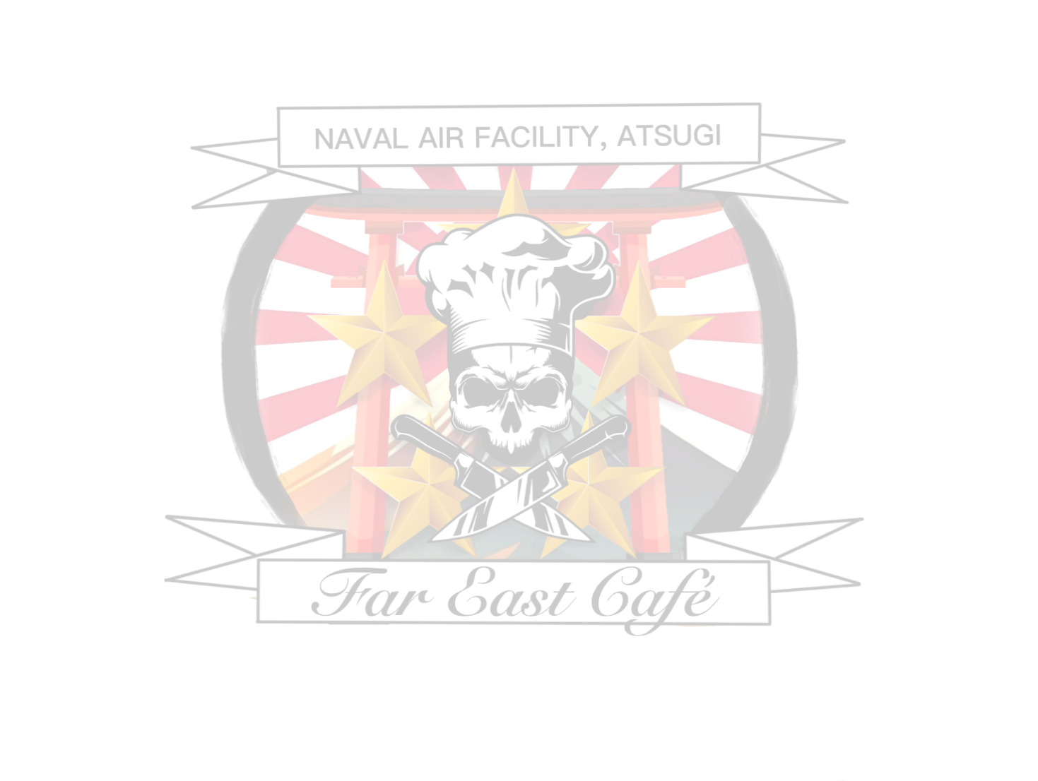  Variety Instant Oatmeal/Granola Bar  Trail Mix / Rice Krispies / PB&J Sandwich  Assorted Pastries / Assorted Bread  Eggs - Scrambled / Hard Boiled  Waffle  Assorted Toppings / Maple Syrup  Longaniza Sausage / Chicken Tocino  Breakfast Burrito  Quick Coffee Cake  Made to Order on Grill: Omelet / Fried Eggs | Sweet & Sour Pork  Chicken Adobo  Steamed Jasmine Rice  Pancit  Baked Lumpia  Boiled Broccoli  Whole Kernel Corn  Egg Drop Soup  Dessert: Carrot Cake  Salad Bar | Salisbury Steak  Onion Lemon Baked Fish  Seasoned Egg Noodles  Steamed Jasmine Rice  Oriental Vegetable Stir Fry  Boiled Asparagus  Egg Drop Soup  Dessert: Devil’s Food Cakeot Cake  Salad Bar
T  U  E  Jul  21st | Variety Instant Oatmeal/Granola Bar  Trail Mix / Rice Krispies / PB&J Sandwich  Assorted Pastries / Assorted Bread  Eggs - Scrambled / Hard Boiled  French Toast  Assorted Toppings / Maple Syrup  Oven Fried Turkey Bacon  Grilled Sausage Patties  Home Fried Potatoes / Quick Coffee Cake  Made to Order on Grill: Omelet/ Fried Eggs | Mexican Pepper Steak  Chalupas  Spanish Rice  Refried Beans  Stewed Tomatoes  Mexcan Corn  Spanish Soup  Dessert: Spice Cake  Salad Bar | Cajun Roast Beef  Chicken Alfredo w/Penne  Toasted Garlic Bread  Mashed Potatoes w/ Gravy  Collard Green  California Vegetable Medley  Spanish Soup  Dessert: Spice Cake  Salad Bar
W  E  D  Jul  22nd | Variety Instant Oatmeal/Granola Bar  Trail Mix / Rice Krispies / PB&J Sandwich  Assorted Pastries / Assorted Bread  Eggs - Scrambled / Hard Boiled  Classic Pancakes  Assorted Toppings / Maple Syrup  Grilled Bacon / Creamed Ground Beef  Hash Brown Potatoes / Quick Coffee Cake  Made to Order on Grill: Omelet/ Fried Eggs | GALLEY ALL HANDS SPECIAL MEAL  BBQ Grilled Homemade W-burger  Hot-Dog w/ Variety Condiments  Sweet Potato Fries / Baked Beans  Corn on the Cob / Green Bean Casserole  Broccoli Cheese Soup / Potato salad  Dessert: Assorted Cookies  Salad Bar / Fruit Bar  NAFA Galley Special Meal:  1030-1230 Main Galley BLDG#983  (All Hands $7.25, E4 and below $5.55) | Beef Stroganoff  Grilled Fish (Pollock)  Steamed Jasmine Rice  Egg Noodles  Fried Cabbages  Calico Corn  Broccoli Cheese Soup  Dessert: Chocolate Chip Cookies  Salad Bar
T  H  U  Jul  23rd | Variety Instant Oatmeal/Granola Bar  Trail Mix / Rice Krispies / PB&J Sandwich  Assorted Pastries / Assorted Bread  Eggs - Scrambled / Hard Boiled  Waffles / Maple Syrup / Assorted Toppings  Chicken Tocino / Corned Beef Hash  Breakfast Rice / Quick Coffee Cake  Made to Order on Grill: Omelet/ Fried Eggs | Apple Glazed Corned Beef  Fried Chicken  Steamed Rice  Quick Baked Potato Halves  Succotash  Italian Vegetable Medley  New England Clam Chowder  Dessert: Chocolate Pudding  Salad Bar | Rotisserie Chicken Quarters  Pasta Toscano  Toasted Garlic Bread  Garlic Roasted Potato Wedges  Oriental Vegetable Stir Fry  Carrot Slices  New England Clam Chowder  Dessert: Chocolate Pudding  Salad Bar
F  R  I  Jul  24th | Variety Instant Oatmeal/Granola Bar  Trail Mix / Rice Krispies / PB&J Sandwich  Assorted Pastries / Assorted Bread  Eggs - Scrambled / Hard Boiled  French Toast / Assorted Toppings / Maple Syrup  Grilled Sausage Links  Oven Fried Turkey Bacon  Tater Tots / Quick Coffee Cake  Made to Order on Grill: Omelet/ Fried Eggs | Chicken Curry  Japanese Fried Pork TON-KATSU  Steamed Jasmine Rice  Parsley Buttered Potatoes  Green Beans  Cauliflower Au Gratin  Chicken Noodle Soup  Dessert: Apple Cobbler  Salad Bar | Chicken Cordon Bleu  Meatball Hoagie  Long Grain & Wild Rice  Sweet Potato Fries  Oriental Stir Fry Cabbages  Corn on the Cob  Chicken Noodle Soup  Dessert: Assorted Gelatin  Salad Bar

